File Code: | 2600 Wildlife | Date: | February 5, 2019
Re: | 2019 International Exchange Visitor:  Wildlife Biologist  Volunteer Opportunity  Early April – Early October 2019
To: | Interested Wildlife Biologists with Ornithology and Conservation Education Experience
 | Application Deadline is February 27, 2019
The Willamette National Forest will again host an International Visiting Wildlife Biologist in 2019. This volunteer opportunity is open to all current and future wildlife biologists who reside outside the U.S., and who have some experience with ornithology and conservation education. Current international students living in the U.S. are eligible to apply. One purpose of this program is to develop and strengthen professional and personal ties between foreign nationals, U.S. citizens, and institutions. These people-to-people programs enable government visitors to understand and experience U.S. culture and society, and contribute to our knowledge of foreign cultures. Feedback from past participants and others involved has helped to strengthen this program over many years. The Forest Service is an organization that is recognized nationally and internationally as a leader in natural resource conservation. If you would like to find out more about the U.S. Forest Service and our mission, please check our website: http://www.fs.fed.us/aboutus/mission.shtml

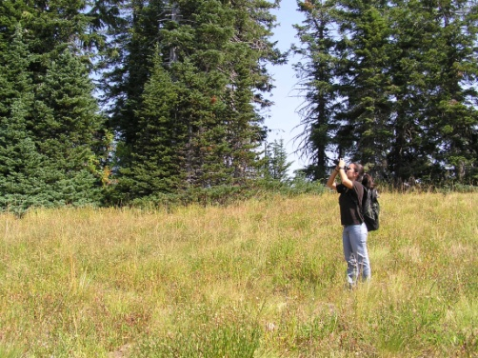
Since 1992, we have hosted twenty-six biologists from Mexico, Colombia, Peru, Nicaragua, Costa Rica, Guatemala, Ecuador, Ireland, South Africa, Zimbabwe, Bhutan, Austria, and Germany between one and nineteen months. Visiting biologists are directly involved in district and forest wildlife program activities.

The nearby HJ Andrews Experimental Forest offers the opportunity to exchange information with forest researchers. In some years other agency biologists (Oregon Department of Fish and Wildlife, U.S. Fish & Wildlife Service, U.S. Army Corps of Engineers, and others) have also been involved in this program to exchange technical information related to management and research.

The following are the projected timeframes for 2018:

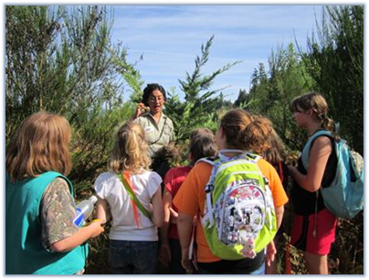
April-June 30: Orientation to the McKenzie River Ranger District, obtain Oregon State and U.S. government driver’s license. Provide and outreach a program of conservation education activities for schools and community organizations. Conduct bald eagle, peregrine falcon, harlequin duck and Pacific pond turtle surveys. Also assist with other district wildlife restoration and survey projects. In mid-June, attend a one week new employee orientation class.

July 1-October: Several days working on conservation education projects and events i.e. Girls in the Woods and Explorer’s Camp. Present an education topic to the Youth Conservation Corps crews. Assist with Diamond Peak Wilderness Bioblitz for one week which includes backpacking with other biologists. Continue to assist with other district wildlife and work as needed. Sierra Nevada Red Fox, Western Bumble Bee and Suckley Cuckoo Bumble Bee surveys. The volunteer projects include coordinating other volunteers, as well as maintaining project files and reports.

Limited time will be spent working independently on a project, depending on individual interests and organizational needs. This offers a valuable learning experience, and depending on the project, allows more integration in district programs and the community. In exchange, we hope to learn more about how natural resource management work is planned and implemented in other countries to generate additional ideas for our work here, as well as to encourage international cooperation and a better understanding of other countries. In 2019, there will be an opportunity to assist with monitoring for and implementation of an extensive floodplain restoration project that benefits many aquatic species. There may be limited opportunity to learn about and assist with projects in other areas such as botany, fisheries, hydrology, archeology, fire, forestry or recreation.

Individual projects in 2019 may include but are not limited to:

- Continue to develop and implement the Conservation Education program for schools and the local community, with an emphasis on more immersion (full day or longer)
- Develop and write a Management Plan for a designated Special Habitat Area
- Amphibian monitoring and development of a monitoring plan
- Development of a photo display of species the district is particularly interested in for wildlife sightings
- Work with other biologists to provide wildlife input to a district project
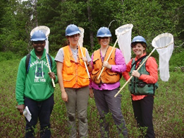
- Geographic Information Systems (GIS) work using ARCMAP (beginning and intermediate courses are offered)

We are open to suggestions concerning other possible projects.

In 2019, the visiting biologist will stay through September 30. This timeframe could be extended, and is funding-dependent.

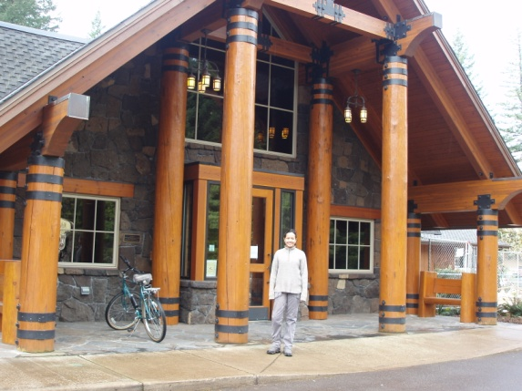
Before we select an individual to participate in this year's program, their goals and interests, as well as possible work projects which the Forest Service can offer will be discussed. This will help ensure that expectations on both sides can be met. After arrival in Oregon, additional details and timeframes will be planned.

Logistics: All travel and visa-related expenses will be paid by the Willamette National Forest. Expenses covered will include roundtrip airfare from your country, the required medical insurance coverage while in the U.S., as well as basic housing in our bunkhouse which accommodates up to four occupants. While past biologists have oftentimes had their own room, you may need to share with one other person. A per diem allowance adequate to cover food and incidental expenses will be paid by the Willamette National Forest. The workweek is 5 days with generally two days off on weekends, although there will be a few weekend events to participate in with equal time off to compensate. Some work may include walking in steep, brushy terrain with poor footing. Working in the woods requires long sleeved shirts, long pants, and leather boots. Safety equipment like hard hats, gloves, and eye protection are provided and required. Our safety record is exceptional and we want to keep it that way. After hours activities include hiking, biking, and swimming. Visitors in the bunkhouse where you will stay in a shared apartment are welcome, but should plan to stay offsite (nearby campgrounds or motels).
You will be required to obtain a J1 Exchange Visitor visa which we can help you obtain. You will need to visit the U.S. Consulate in your country to obtain this visa. For some countries, you would need to pay $100 U.S. for the J1 visa. In addition, there is a $100 SEVIS fee payable to the Department of Homeland Security which you would also need to prepay by credit card. We can reimburse you for these expenses. Please be sure to keep your receipts as they are needed for reimbursement.
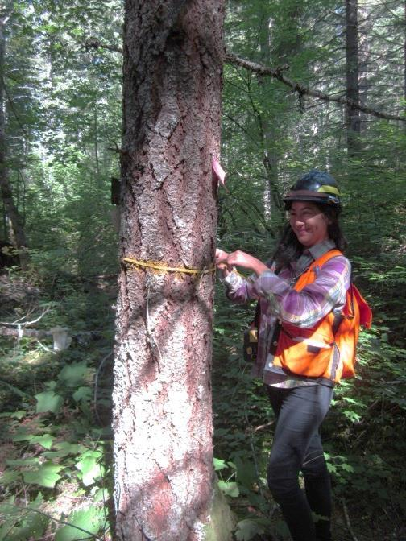
The Willamette Program is supported by our Washington office international programs staff, and more useful information may be found here: http://www.fs.fed.us/global/visitor_program/welcome.htm
Please take some time to review the following website that lists information about the different types of visas and in particular the J1 visa which you would have: http://travel.state.gov/visa/temp/types/types_1267.html

Program Requirements:

- At least 2 years college in a natural resources or biology curriculum, or comparable work experience.

- Be able to leave your home country in early April and stay until September 30 (with some flexibility for the return date).

- Applicants must be residents from a foreign country but may be current students living in the U.S. who plan to return to their home country upon completion of their current visa program.

- To participate in this program, applicants need to already have a good comprehension of English. They must have a good ability to speak and read English to adequately understand biological and other work-related information.

- Some experience with fieldwork
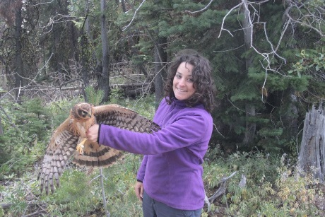
- Knowledge and some experience with birds

- Plant identification and botany courses

- Experience with and a strong interest in conservation education in schools and with community organizations

- Public speaking skills

- Strong interest in integrated natural resource management.

- Valid driver’s license for your own country, excellent driving record and experienced driver including on gravel and dirt roads. Ability to obtain an Oregon and U.S. Government Driver’s License. Please note that meeting this requirement is critical, i.e. applicants without a driver’s license cannot be considered.

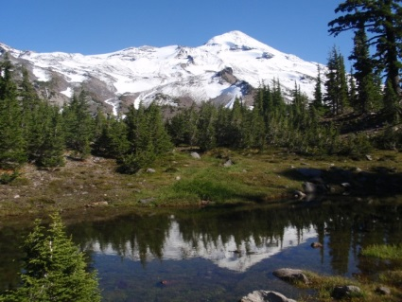
- A passport valid for travel to the United States and with a valid date at least six months beyond the timeframe of your projected stay in the United States (unless country-specific agreements provide exemptions).

- Field conditions in the dense forests of western Oregon can be quite arduous, and require that an individual is in good physical condition, and tolerant of a range of weather conditions including wet, cold, foggy and rainy weather. Late spring and early summer weather in the Oregon Cascade Mountains can be quite chilly, especially for visitors not accustomed to high humidity and cold rain. Through June you may experience snowy conditions. Late summer weather in the Cascades is usually hot, dry and may be smoky due to wildfires. Snows may return in October, although they don’t generally last until November. Field conditions especially during the wilderness bioblitz generally include swarms of mosquitoes.

Application Information:
If you are interested in applying for this opportunity, please email, fax, or mail the following information.

1. Your responses to the applicant questions (see Attachment 1)
2. Resume/Curriculum Vitae
3. List of three references, including their current address, phone number, and email.

Please note that incomplete applications or those received after the February 27, 2019 deadline will not be considered. You may email your application information to ruseitz@fs.fed.us

McKenzie River Ranger District
Attn: Ruby Seitz, Wildlife Biologist
57600 McKenzie Highway
McKenzie Bridge, OR 97413 USA
Phone: (541)822-7256, fax: (541)822-7254

Prior to making an applicant selection, you will be interviewed on the phone in English to discuss your objectives for participating in this program, as well as how working here will benefit you after returning to your country. If you have questions about this opportunity, contact Ruby Seitz at the McKenzie River Ranger District.

/s/ Darren Cross
District Ranger
McKenzie River Ranger District

Attachment 1 - Applicant Questions:

- Please rank your English ability in the table below by checking the appropriate box :

 | Understanding spoken language | Speaking ability | Writing ability
Fluent
Excellent
Good
Fair
Poor

- What is your English background and experience?

- Please write a brief description of your current student and/or professional activities.

- Please describe below if you have had any coursework or practical work experience as shown in the table. While some experience is desirable, having experience in all of these categories is not required to be considered for this opportunity.

 | Coursework or Field Training | Practical Experience
Bird Identification
Natural Resource Education
Mammalogy
Entomology
Map and Compass, GPS Use
Wilderness Hiking and Backpacking

- Rank your level of bird identification expertise (beginner, intermediate, advanced, or expert) and describe where you obtained birding experience.

- Do you have any experience with natural resource education or public speaking in your native language or English?

- Would you be comfortable engaging youth in natural resource education using the arts? Briefly explain how you would do this, i.e. drawing, painting, drama, music, or writing, etc.

- The McKenzie River Ranger District on the Willamette National Forest is involved in active forest management which involves all disciplines. How would an experience working with wildlife and other natural resources personnel in Oregon benefit you and your home country? What skills and knowledge would you like to learn?

- Does your home country have temperate coniferous forests and does your current work, or your future work goals, involve working in a forested setting?

- What are your long-term career goals?

- What can you offer the Forest Service in terms of work/experience sharing?

- Do you have any slide presentations/talks that you could give to the district, forest biologists, or the public?

- What computer skills do you have?

- Do you have a valid driver's license?

- How many years of driving experience have you had, and what is your driving record? Please provide background about your driving experience in both urban and rural settings, including use of 4WD and driving on single lane gravel roads that may have other traffic on them.

- Please describe your general strengths and weaknesses.

- How did you hear about this opportunity?

Thank you for taking the time to respond to the applicant questions! You will receive a response about your application status by March 5, 2019.
Attachment 2 – Additional Information about the Community

ABOUT THE WILLAMETTE NATIONAL FOREST:
The Willamette National Forest is a large, complex forest, encompassing over 1.6 million acres in Oregon, which stretches for 110 miles along the western slopes of the Cascades. There are five Districts, an experimental forest, and a diverse and challenging program of work. It is known for its numerous volcanic peaks, the forested Cascade Range, and its outstanding rivers. For more information, visit the forest’s website at: www.fs.usda.gov/willamette

ABOUT THE MCKENZIE RIVER RANGER DISTRICT & COMMUNITY:

The McKenzie River Ranger Station is located about 50 miles east of the Eugene/Springfield metro area on Highway 126 near the small community of McKenzie Bridge. McKenzie Bridge is one of nine small communities located in the McKenzie River valley between the cities of Eugene and Bend. The community of Blue River is located about 16 miles from the Ranger Station. Limited services found in these two communities include restaurants, lodging, groceries, gas, churches and a medical clinic. Daily bus service from the Eugene area to the Ranger Station is available for more complete shopping or entertainment needs.

The climate in the area is typical for the west side of the Oregon Cascade Mountain Range. The average rainfall is 65 inches annually, occurring mostly from October to April. The Ranger Station is located at 1600 feet elevation and sees snow on occasion during the winter months. At higher elevations, winter snows accumulate and persist until mid-summer. Summertime temperatures range from the high 80s to the mid 50s, with lows in the 30s at higher elevations.

The McKenzie River valley offers a wide variety of recreation opportunities. Nearly 500 miles of public trails are available on the McKenzie River Ranger District (formerly Blue River and McKenzie Ranger Districts), including two National Scenic Trails. Other summer outdoor offerings include mountain bicycling, whitewater rafting and kayaking, and golfing. The Ranger Station is situated on two nationally designated scenic byways, providing scenic vistas of waterfalls, interpretive trails and mountain landscapes. The district includes the HJ Andrews Experimental Forest, internationally known for its’ research in ecological studies and ecosystem processes.

ABOUT THE EUGENE/SPRINGFIELD COMMUNITY
Eugene http://www.eugene-or.gov/portal/server.pt is located in the Willamette Valley, with the Cascade Mountain Range to the east and the Coast Range to the west. It is about 110 miles south of Portland, Oregon. The population is 126,325 within Eugene and 50,150 in adjacent Springfield http://www.ci.springfield.or.us/ . Eugene is known as the "Track and Field Capital of the United States" hosted the Olympic Track Trials during the summer of 2008, 2012, and 2016. Both Eugene and Springfield are located in Lane County http://www.visitlanecounty.org/. Average temperatures range from 37 F to 49 F in December and 51 F to 82 F in August. Average yearly rainfall is 47 inches, which occurs primarily from October to April. Significant snowfall in the valley is rare, however it occasionally snows in McKenzie Bridge between December and March, and sometimes the snow remains for a few weeks.

